PC2232 Physics for Electrical Engineers
Some exercise on Atomics Spectra and Bohr Model

- Which of the following is not true regarding the atomic spectrum?

  - When all of a large group of excited Hydrogen atoms at n=4 states eventually return to the ground state, photons with 3 different wavelengths are emitted.
  - Absorption spectrum is obtained when white light shines through a gaseous cloud of the cold atoms.
  - Emission spectrum is unique for each atom. It can be used to identify the type of atom.
  - Though an excited Helium Lamp may appear red in color, it does not mean that there is only one type of photons emitted by the excited Helium atoms.
  - Not all the emission spectra of the hydrogen atom are in the visible light region.
ANSWER: (A)

- Which of the following is not true regarding the hydrogen atoms?
  - The energy of the system is quantized.
  - The energy difference between one energy level and the next higher energy level decreases with increasing quantum number n.
  - The electron is in a confining potential.
  - The emission spectra of the hydrogen atom are all in the visible light region.
  - The properties of the electron are described by a probability wave function.
ANSWER: (D)

- A light source is emitting photons with a fixed wavelength of λ. The light is shined onto a gas of atomic hydrogen, all of which is in the ground state. It was found that such illumination of light causes an excitation in the hydrogen atoms which subsequently emit Balmer line photons (i.e. transition from higher excited states into the n=2 state)? Which of the following wavelengths does not correspond to the possible values for λ?

  - λ= 121.88 nm
  - λ= 102.83 nm
  - λ= 97.50 nm
  - λ= 95.21 nm
  - λ= 94.02 nm
ANSWER: (A)

- An electron collides with a gas of atomic hydrogen, all of which is in the ground state. What is the minimum energy (in eV) the electron must have to cause the hydrogen to emit a Paschen line photon (i.e. transition from higher excited state into the n=3 state)?
  - 13.60 eV
  - 12.75 eV
  - 12.09 eV
  - 11.91 eV
  - 10.40 eV
ANSWER: (B)

- The energy levels in a hydrogen atom is written as E_{n} = -13.6/n² (unit = eV). Here n refers to the quantum number. The energy levels in a hydrogen atom are shown in the following figure. A gas of excited hydrogen atoms emits photons of various wavelengths. Which of the following emitted photons come from the gas of excited hydrogen atoms? Photos with energies of (I) 12.98eV, (II) 12.32eV (III) 12.09eV (IV) 11.41eV (V) 10.20eV.
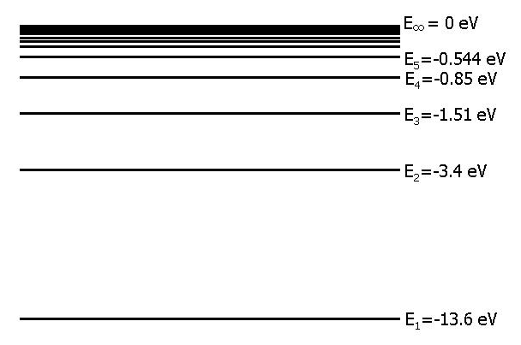
  - (I) and (II)
  - (II) and (IV)
  - (III)
  - (I) and (III)
  - (III) and (V)
ANSWER: (E)
- A light source is emitting photons with a fixed wavelength of λ. The light is shined onto a gas of atomic hydrogen, all of which is in the ground state. It was found that such illumination of light causes an excitation in the hydrogen atoms which subsequently emit Paschen line photons (i.e. transition from higher excited states into the n=3 state)? Which of the following wavelengths does not correspond to the possible values for λ?
  - λ= 102.83 nm
  - λ= 97.50 nm
  - λ= 95.21 nm
  - λ= 94.02 nm
  - λ= 93.31 nm
ANSWER: (A)

Challenging Problem

- An atom has energy level E_{n} = -A/n² where n is an integer and A is a constant. Among the spectral lines that the atom can absorb at room temperature are two adjacent lines with wavelength 97.5 nm and 102.8 nm. Find the value of the constant A in electron volts.

